**DAY 1**

**EXPERIMENT-1**: LEX program to identify the capital words from the given input.

%{

%}

%%

[A-Z]+[\t\n ] { printf("%s is a capital word\n",yytext); }

.|\n ;

%%

int yywrap( )

{

return 1;

}

int main( )

{

printf("Enter String :\n");

yylex();

}

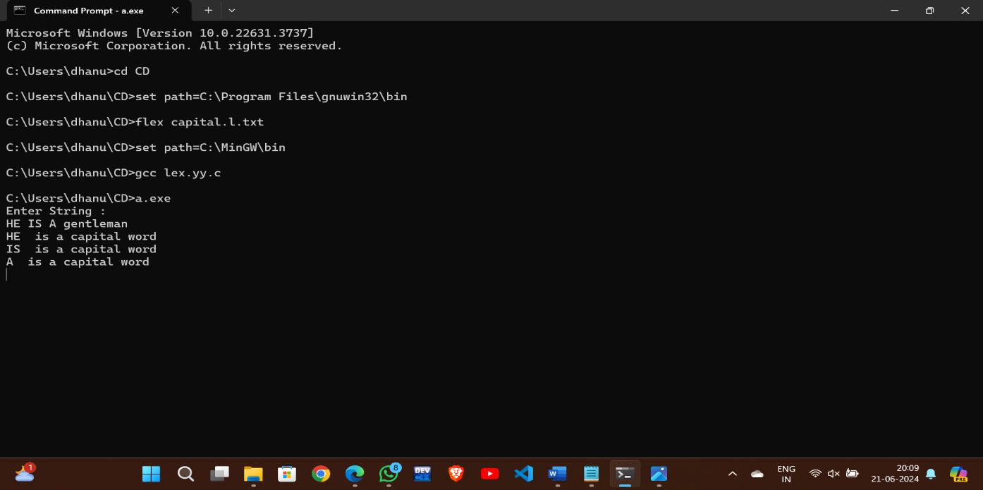

**EXPERIMENT-2**: LEX program to check whether the given input is digit or not.

%{

%}

%%

[0-9] { printf("Input is a digit: %s\n", yytext); }

. { printf("Input is not a digit: %s\n", yytext); }

%%

int yywrap() {

return 1;

}

int main() {

printf("Enter input: ");

yylex();

return 0;

}

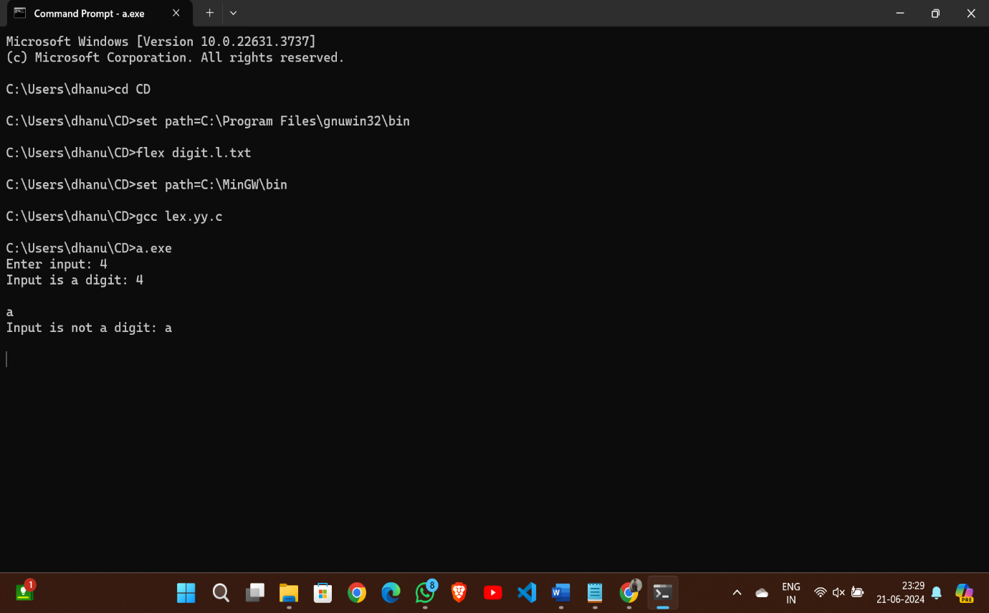

**EXPERIMENT-3**: LEX program to check whether the mobile number is valid or not.

%{

%}

%%

[6-9][0-9]{9} {printf("\nMobile Number Valid\n");}

.+ {printf("\nMobile Number Invalid\n");}

%%

int yywrap(){}

int main()

{

printf("\nEnter Mobile Number : ");

yylex();

printf("\n");

return 0;

}

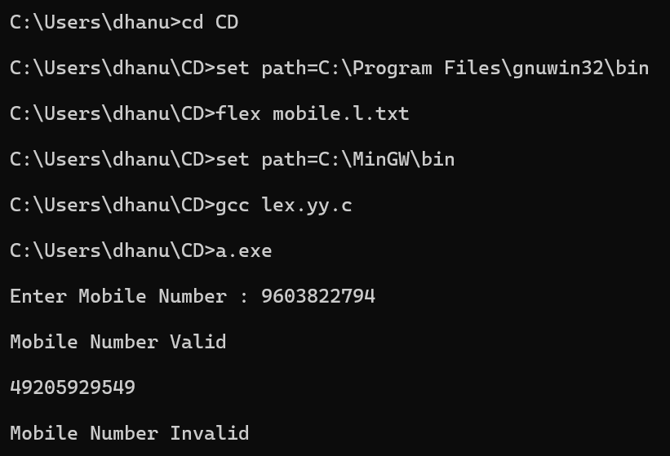

**EXPERIMENT-4**: LEX program count the number of vowels and consonants in the given sentence.

%{

int vow_count=0;

int const_count =0;

%}

%%

[aeiouAEIOU] {vow_count++;}

[a-zA-Z] {const_count++;}

%%

int yywrap(){}

int main()

{

printf("Enter the string of vowels and consonants:");

yylex();

printf("Number of vowels are: %d\n", vow_count);

printf("Number of consonants are: %d\n", const_count);

return 0;

}

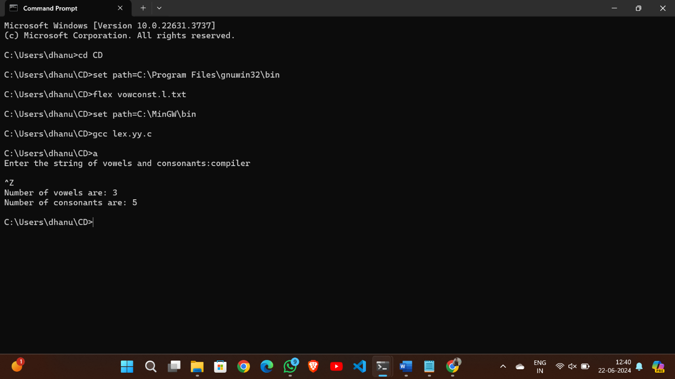

**EXPERIMENT-5**: LEX program to separate keywords and identifiers.

%{

%}

%%

"if"|"else"|"while"|"return"|"int"|"float"|"char" { printf("Keyword: %s\n", yytext); }

[a-zA-Z_][a-zA-Z0-9_]* { printf("Identifier: %s\n", yytext); }

[ \t\n]+

. { printf("Unknown character: %s\n", yytext); }

%%

int yywrap()

{

return 1;

}

int main()

{

printf("Enter the input:");

yylex();

return 0;

}

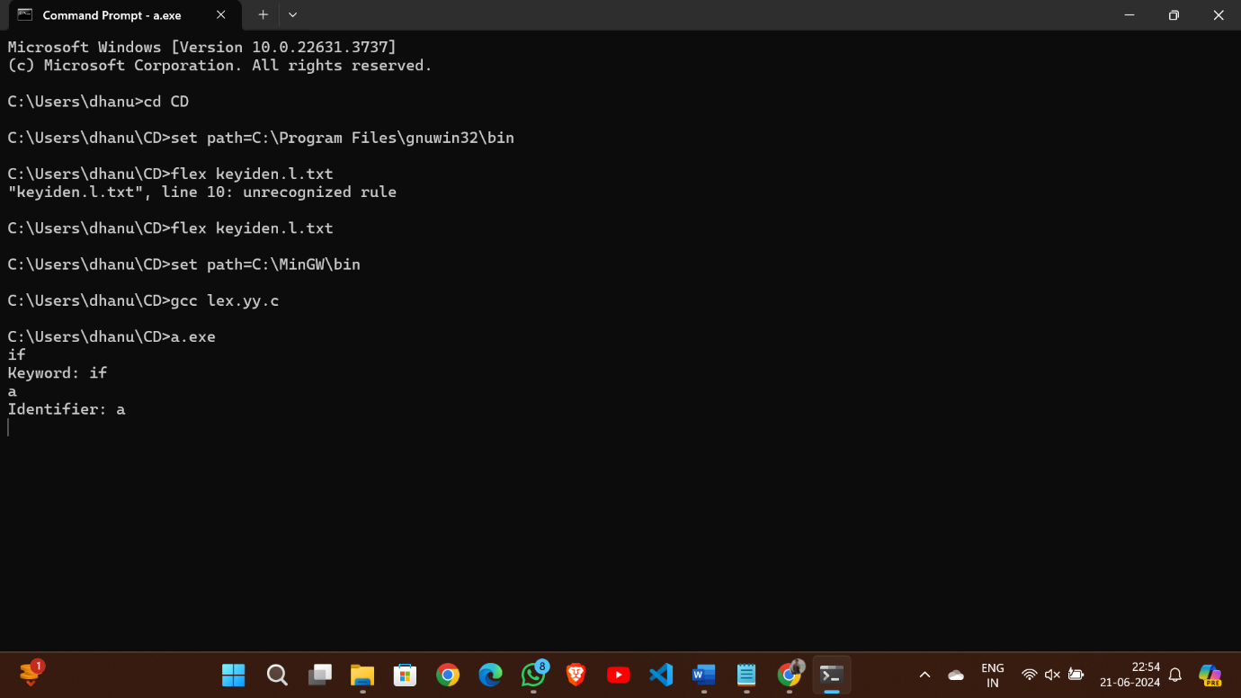

**EXPERIMENT-6**: LEX program to identify and count positive and negative numbers.

%{

int positive_no = 0, negative_no = 0;

%}

%%

^[-][0-9]+ {negative_no++; printf("negative number = %s\n", yytext);}

[0-9]+ {positive_no++; printf("positive number = %s\n", yytext);}

%%

int yywrap(){}

int main()

{

printf("Enter the number:");

yylex();

printf ("number of positive numbers = %d," "number of negative numbers = %d\n", positive_no, negative_no);

return 0;

}

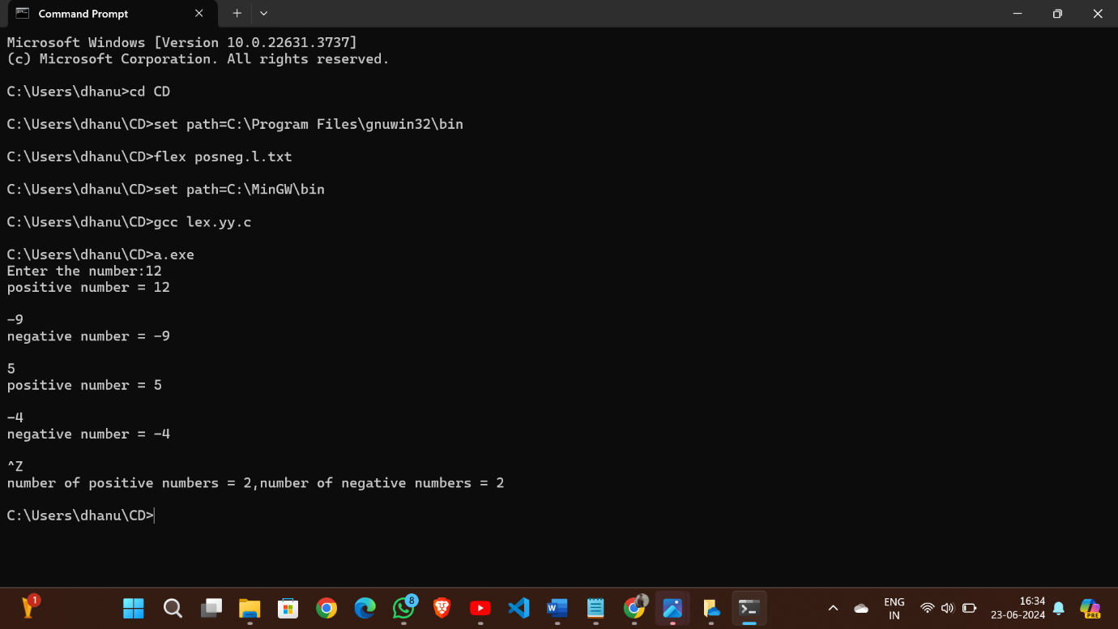

**EXPERIMENT-7**: LEX program to recognise numbers and words in a statement.

%{

%}

%%

[0-9]+ { printf("Number: %s\n", yytext); }

[A-Za-z]+ { printf("Word: %s\n", yytext); }

[ \t\n]+

. { printf("Unknown character: %s\n", yytext); }

%%

int yywrap()

{

return 1;

}

int main()

{

printf("Enter the statement:");

yylex();

return 0;

}

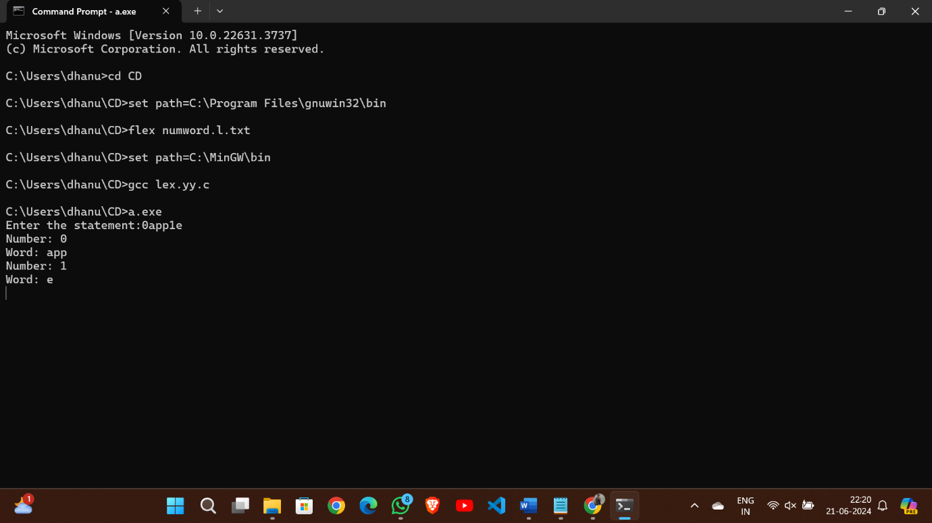

**EXPERIMENT-8**: LEX program to accept string starting with vowel.

%{

%}

%%

^[aeiouAEIOU].* { printf("Accepted: %s\n", yytext); }

.* { printf("Rejected: %s\n", yytext); }

%%

int yywrap()

{

return 1;

}

int main()

{

printf("Enter the string: \n");

yylex();

return 0;

}

